Generic Carry Look Ahead

DUT:

Sum Block:
module Sum_blk #(
parameter N = 4
) (
input logic [N - 1 : 0] p_i ,
input logic [N - 1 : 0] cin ,

output logic [N - 1 : 0] sum_o
);

assign sum_o = p_i ^ cin ;
endmodule

G/P Generator:
module gp_gen #(
parameter DATA_WIDTH = 4
)(
input logic [DATA_WIDTH-1:0] x_i ,
input logic [DATA_WIDTH-1:0] y_i ,

output logic [DATA_WIDTH-1:0] g_o ,
output logic [DATA_WIDTH-1:0] p_o
);

// Generate signals
assign g_o = x_i & y_i ;

// Propagate signals
assign p_o = x_i ^ y_i ;
endmodule

4-Bit CLA:
module cla_4bit (
input logic cin ,
input logic g0_i ,
input logic p0_i ,
input logic g1_i ,
input logic p1_i ,
input logic g2_i ,
input logic p2_i ,
input logic g3_i ,
input logic p3_i ,
output logic c1_o ,
output logic c2_o ,
output logic c3_o ,
output logic c4_o ,
output logic p_o ,
output logic g_o
);

// Carry-out calculations
assign c1_o = g0_i | (p0_i & cin) ;

assign c2_o = g1_i | (p1_i & g0_i) | (p1_i & p0_i & cin) ;

assign c3_o = g2_i | (p2_i & g1_i) | (p2_i & p1_i & g0_i) | (p2_i & p1_i & p0_i & cin) ;

assign c4_o = g3_i | (p3_i & g2_i) | (p3_i & p2_i & g1_i) | (p3_i & p2_i & p1_i & g0_i) | (p3_i & p2_i & p1_i & p0_i & cin) ;

// Group Propagate and Generate
assign p_o = p3_i & p2_i & p1_i & p0_i ;

assign g_o = g3_i | (p3_i & g2_i) | (p3_i & p2_i & g1_i) | (p3_i & p2_i & p1_i & g0_i) ;

endmodule

Top:
module CLA_top #(
parameter int DATA_WIDTH = 64 // Width of the adder in bits (default 64-bit)
)(
input logic [DATA_WIDTH-1:0] A, // First operand input
input logic [DATA_WIDTH-1:0] B, // Second operand input
input logic cin, // Carry input
output logic [DATA_WIDTH-1:0] sum, // Sum output
output logic cout // Carry output
);

// Calculate number of 4-bit groups needed (e.g., 64 bits / 4 = 16 groups)
localparam int NUM_GROUPS = DATA_WIDTH / 4;
// Calculate tree depth: log4(NUM_GROUPS) = log2(NUM_GROUPS)/2
// Each level combines 4 groups from previous level into 1 group
localparam int NUM_LEVELS = ($clog2(DATA_WIDTH)/2);

// Bit-level signals from initial GP generation
logic [DATA_WIDTH - 1 : 0] g_vector; // Generate: G[i] = A[i] & B[i] (both bits are 1)
logic [DATA_WIDTH - 1 : 0] p_vector; // Propagate: P[i] = A[i] ^ B[i] (carry will propagate through)

// Hierarchical group-level GP signals
// [NUM_LEVELS:0] represents levels 0 through NUM_LEVELS
// Level 0: 4-bit groups, Level 1: 16-bit groups, Level 2: 64-bit groups, etc.
logic [NUM_LEVELS : 0] g_group [NUM_GROUPS - 1 : 0]; // Group generate signals
logic [NUM_LEVELS : 0] p_group [NUM_GROUPS - 1 : 0]; // Group propagate signals

// Carry chain: carry_vector[i] is the carry into bit position i
logic [DATA_WIDTH:0] carry_vector;

// Generate bit-level G and P for all bit positions
// G[i] = A[i] & B[i]: this position generates a carry
// P[i] = A[i] ^ B[i]: this position will propagate an incoming carry
gp_gen #(
.DATA_WIDTH(DATA_WIDTH)
) GP_GENERATOR (
.x_i (A) ,
.y_i (B) ,
.g_o (g_vector) ,
.p_o (p_vector)
);

// Initialize carry chain with input carry
assign carry_vector[0] = cin;

// ========== LEVEL 0: Process individual bits into 4-bit groups =========
// For 64-bit: creates 16 groups, each handling 4 consecutive bits
generate
for (genvar i = 0 ; i < NUM_GROUPS ; i++) begin
localparam int OFFSET = i * 4; // Starting bit index: 0, 4, 8, 12, ...
logic c1, c2, c3, c4; // Intermediate carries within this 4-bit group

// Each cla_4bit computes:
// - Individual carries c1, c2, c3, c4 for bits within the group
// - Group-level G and P that represent the entire 4-bit block
// Group G = G3 | (P3&G2) | (P3&P2&G1) | (P3&P2&P1&G0)
// Group P = P3 & P2 & P1 & P0
cla_4bit gp4 (
.cin(carry_vector[OFFSET]), // Carry into this 4-bit group
.g0_i(g_vector[OFFSET]), // Bit 0 generate
.p0_i(p_vector[OFFSET]), // Bit 0 propagate
.g1_i(g_vector[OFFSET + 1]), // Bit 1 generate
.p1_i(p_vector[OFFSET + 1]), // Bit 1 propagate
.g2_i(g_vector[OFFSET + 2]), // Bit 2 generate
.p2_i(p_vector[OFFSET + 2]), // Bit 2 propagate
.g3_i(g_vector[OFFSET + 3]), // Bit 3 generate
.p3_i(p_vector[OFFSET + 3]), // Bit 3 propagate
.c1_o(c1), // Carry out of bit 0: C1 = G0 | (P0&Cin)
.c2_o(c2), // Carry out of bit 1: C2 = G1 | (P1&G0) | (P1&P0&Cin)
.c3_o(c3), // Carry out of bit 2
.c4_o(c4), // Carry out of bit 3 (= carry out of entire 4-bit group)
.p_o(p_group[0][i]), // Level 0 group propagate for group i
.g_o(g_group[0][i]) // Level 0 group generate for group i
);

// Store computed carries back into the carry vector for sum calculation
assign carry_vector[OFFSET + 1] = c1;
assign carry_vector[OFFSET + 2] = c2;
assign carry_vector[OFFSET + 3] = c3;
assign carry_vector[OFFSET + 4] = c4; // This becomes carry input for next group
end
endgenerate

// ========== LEVELS 1 to NUM_LEVELS: Build hierarchical CLA tree =========
// Each level combines 4 groups from the previous level into 1 parent group
// Level 1: combines 4-bit groups into 16-bit groups
// Level 2: combines 16-bit groups into 64-bit groups, etc.
generate
for (genvar j = 1 ; j <= NUM_LEVELS ; j++) begin : levels
// Number of child groups from previous level
// Level 1: NUM_GROUPS/4^0 = 16 (for 64-bit)
// Level 2: NUM_GROUPS/4^1 = 4
// Level 3: NUM_GROUPS/4^2 = 1
localparam int NUM_CHILD = (NUM_GROUPS / 4**(j - 1));

// Number of parent groups at this level
// Level 1: NUM_GROUPS/4^1 = 4 (16-bit groups)
// Level 2: NUM_GROUPS/4^2 = 1 (64-bit group)
localparam int NUM_PARENT = (NUM_GROUPS / 4**(j));
for (genvar k = 0; k < NUM_PARENT; k++) begin : parents
// Index of first child group that feeds into this parent
// Parent 0 uses children 0-3, Parent 1 uses children 4-7, etc.
localparam int CHILD = k * 4;

// Local GP signals for the 4 child groups
logic g0, p0; // Child group 0
logic g1, p1; // Child group 1
logic g2, p2; // Child group 2
logic g3, p3; // Child group 3

// Fetch GP from child groups with bounds checking
// If child doesn't exist (e.g., only 3 children), use default values
// Default G=0 (no generate), P=1 (transparent propagate)
assign g0 = (CHILD < NUM_CHILD) ? g_group[j - 1][CHILD] : 1'b0;
assign p0 = (CHILD < NUM_CHILD) ? p_group[j - 1][CHILD] : 1'b1;
assign g1 = (CHILD + 1 < NUM_CHILD) ? g_group[j - 1][CHILD + 1] : 1'b0;
assign p1 = (CHILD + 1 < NUM_CHILD) ? p_group[j - 1][CHILD + 1] : 1'b1;
assign g2 = (CHILD + 2 < NUM_CHILD) ? g_group[j - 1][CHILD + 2] : 1'b0;
assign p2 = (CHILD + 2 < NUM_CHILD) ? p_group[j - 1][CHILD + 2] : 1'b1;
assign g3 = (CHILD + 3 < NUM_CHILD) ? g_group[j - 1][CHILD + 3] : 1'b0;
assign p3 = (CHILD + 3 < NUM_CHILD) ? p_group[j - 1][CHILD + 3] : 1'b1;

// Combine 4 child groups into 1 parent group using CLA logic
// Parent G = G3 | (P3&G2) | (P3&P2&G1) | (P3&P2&P1&G0)
// Parent P = P3 & P2 & P1 & P0
// No cin needed here - we're just combining GP signals, not computing carries
cla_4bit COMB (
.cin(1'b0), // Cin=0 for GP combination (not computing actual carries)
.g0_i(g0),
.p0_i(p0),
.g1_i(g1),
.p1_i(p1),
.g2_i(g2),
.p2_i(p2),
.g3_i(g3),
.p3_i(p3),
.c1_o(), // Intermediate carries not needed - only final GP matters
.c2_o(),
.c3_o(),
.c4_o(),
.p_o(p_group[j][k]), // Parent group propagate
.g_o(g_group[j][k]) // Parent group generate
);
end
end
endgenerate

// Final carry out is the carry that would propagate beyond the last bit
assign cout = carry_vector[DATA_WIDTH];

// Compute final sum bits using: Sum[i] = P[i] ^ Carry[i]
// P[i] = A[i] ^ B[i], so Sum[i] = (A[i] ^ B[i]) ^ Carry[i] = A[i] ^ B[i] ^ Carry[i]
Sum_blk #(
.N(DATA_WIDTH)
) SUM (
.p_i (p_vector), // Bit-level propagate (A ^ B)
.cin (carry_vector[DATA_WIDTH-1:0]), // All carry signals (carry into each bit)
.sum_o (sum) // Final sum = (A ^ B) ^ Carry
);

endmodule

Verification:

Testbench:
module top_tb ();

// Testbench parameter - can be overridden for different bit widths
parameter DATA_WIDTH = 64;

// DUT input signals
logic [DATA_WIDTH-1:0] A; // First operand for addition
logic [DATA_WIDTH-1:0] B; // Second operand for addition
logic cin; // Carry input

// DUT output signals
logic [DATA_WIDTH-1:0] sum; // Sum result from CLA
logic cout; // Carry output from CLA

// Counters for test statistics
int passed_tests = 0; // Count of successful test cases
int failed_tests = 0; // Count of failed test cases

// Expected result for comparison
logic [DATA_WIDTH:0] expected_result; // Full width to hold sum + carry

// Instantiate the Device Under Test (DUT)
CLA_top #(
.DATA_WIDTH(DATA_WIDTH) // Pass parameterized width to CLA
) DUT (
.A (A), // Connect operand A
.B (B), // Connect operand B
.cin (cin), // Connect carry input
.sum (sum), // Connect sum output
.cout(cout) // Connect carry output
);

// Main test sequence
initial begin
$display("========================================");
$display("Starting CLA Testbench");
$display("Data Width: %0d bits", DATA_WIDTH);
$display("========================================\n");

// ========== Test 1: Corner Cases ==========
$display("Test 1: Corner Cases");

// Test case 1a: All zeros (minimum values)
A = 0; B = 0; cin = 0;
#5; // Wait for combinational logic to settle
check_result("All zeros");
#5;

// Test case 1b: All ones (maximum values, will overflow)
A = '1; B = '1; cin = 1; // '1 creates all-ones pattern
#5;
check_result("All ones with carry");
#5;

// Test case 1c: Maximum value + 0
A = '1; B = 0; cin = 0;
#5;
check_result("Max + 0");
#5;

// Test case 1d: Carry propagation test (alternating pattern)
A = {DATA_WIDTH{1'b1}}; // All ones
B = 1; // Add 1 to trigger full carry chain
cin = 0;
#5;
check_result("Carry propagation chain");
#5;

// ========== Test 2: Power-of-2 Values ==========
$display("\nTest 2: Power-of-2 Values");

// Test addition of powers of 2 (single bit set)
for (int i = 0; i < DATA_WIDTH; i++) begin
A = (1 << i); // 2^i
B = 0;
cin = 0;
#5;
check_result($sformatf("2^%0d", i));
#5;
end

// ========== Test 3: Alternating Bit Patterns ==========
$display("\nTest 3: Alternating Bit Patterns");

// Pattern: 0x5555... (01010101...)
A = {DATA_WIDTH{2'b01}};
B = {DATA_WIDTH{2'b10}}; // 0xAAAA... (10101010...)
cin = 0;
#5;
check_result("0x5555... + 0xAAAA...");
#5;

// Pattern: Same with carry
A = {DATA_WIDTH{2'b01}};
B = {DATA_WIDTH{2'b10}};
cin = 1;
#5;
check_result("0x5555... + 0xAAAA... + 1");
#5;

// ========== Test 4: Sequential Values ==========
$display("\nTest 4: Sequential Additions");

// Test sequential numbers
for (int i = 0; i < 20; i++) begin
A = i;
B = i + 1;
cin = i % 2; // Alternate carry input
#5;
check_result($sformatf("Sequential %0d", i));
#5;
end

// ========== Test 5: Random Vectors ==========
$display("\nTest 5: Random Test Vectors");

// Comprehensive random testing
repeat (1000) begin
A = $random; // Generate random value for A
B = $random; // Generate random value for B
cin = $random; // Random carry input (0 or 1)
#5;

// Verify result matches expected sum
check_result("Random");

#5;
end

// ========== Test 6: Stress Test - Near Overflow ==========
$display("\nTest 6: Near-Overflow Cases");

// Test values near maximum
for (int i = 0; i < 10; i++) begin
A = ({DATA_WIDTH{1'b1}} - i); // Max - i
B = i;
cin = $random % 2;
#5;
check_result($sformatf("Near-max %0d", i));
#5;
end

// ========== Final Report ==========
$display("\n========================================");
$display("Test Summary:");
$display(" Passed: %0d", passed_tests);
$display(" Failed: %0d", failed_tests);
$display(" Total: %0d", passed_tests + failed_tests);

if (failed_tests == 0) begin
$display(" Status: ALL TESTS PASSED ✓");
end else begin
$display(" Status: SOME TESTS FAILED ✗");
end
$display("========================================\n");

$stop; // Stop simulation
end

// Task to check and report results
// Compares DUT output against expected value and updates statistics
task check_result(string test_name);
// Calculate expected result: full width addition
expected_result = A + B + cin;

// Compare DUT output {cout, sum} with expected result
if ({cout, sum} !== expected_result) begin
// Mismatch detected - report error
$error("[%s] FAIL: A=%0h, B=%0h, cin=%0b => {cout,sum}=%0h, expected=%0h",
test_name, A, B, cin, {cout, sum}, expected_result);
failed_tests++;
end else begin
// Test passed
$display("[%s] PASS: A=%0h + B=%0h + %0b = %0h",
test_name, A, B, cin, {cout, sum});
passed_tests++;
end
endtask
endmodule

Waveform:

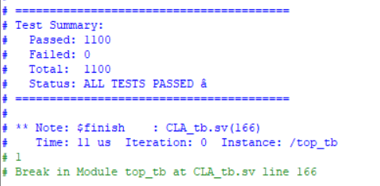

Vivado Results:

Elaboration:
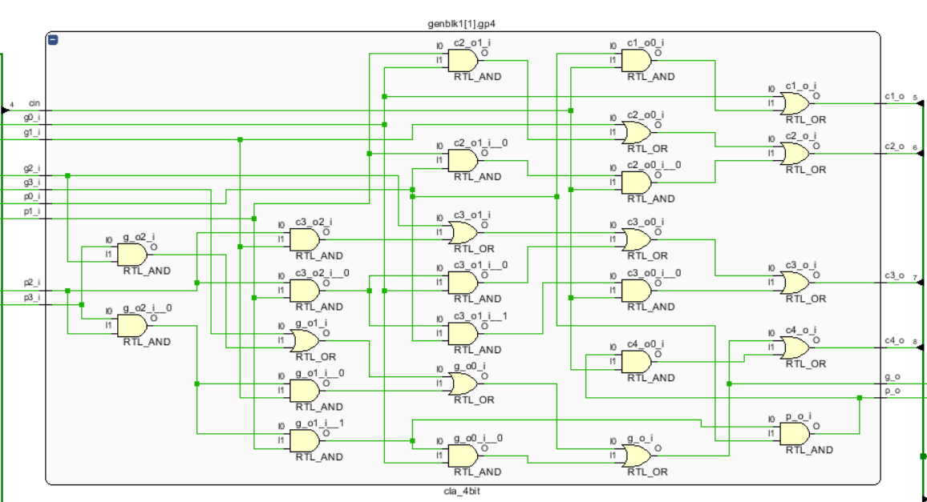
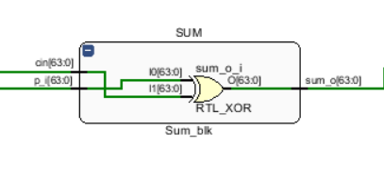
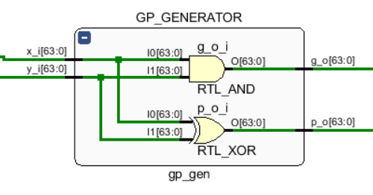

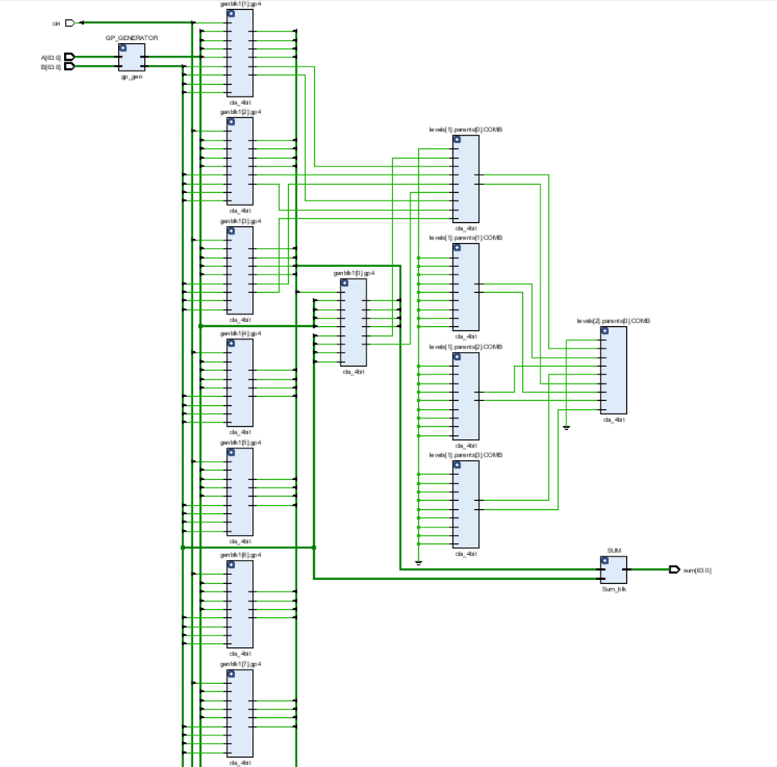

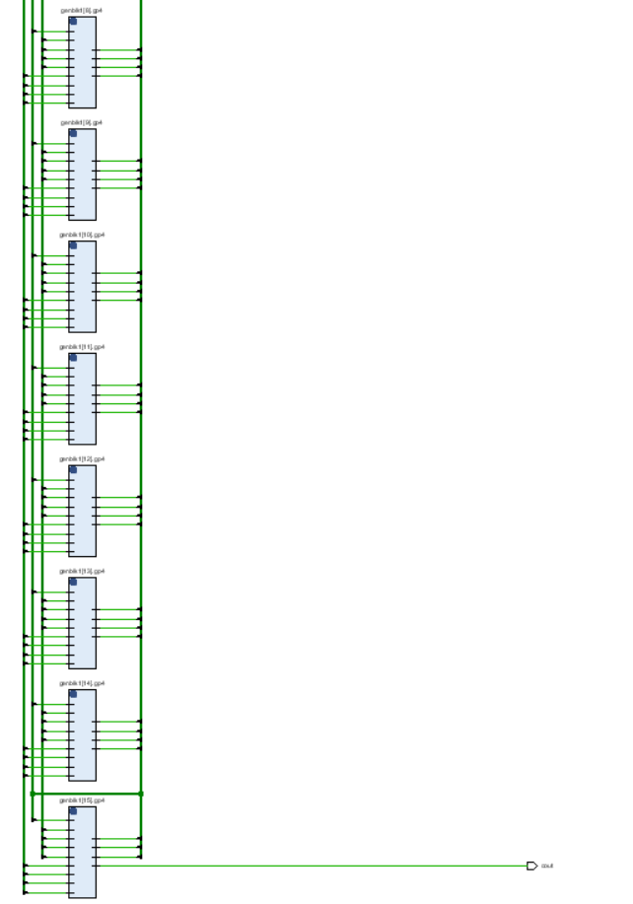

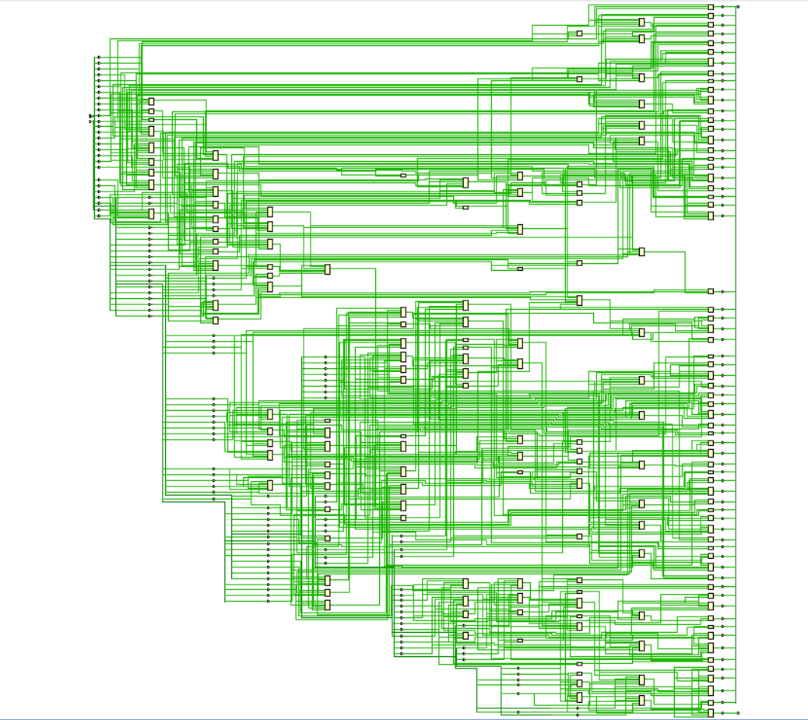
Synthesis:

Synthesis Utilization Analysis:
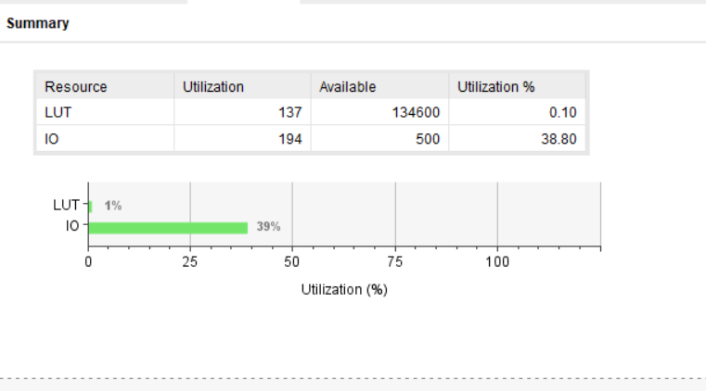

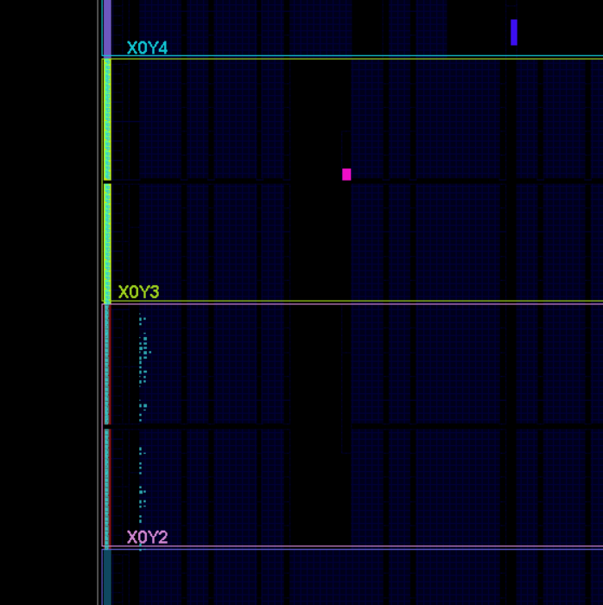
Implementation:

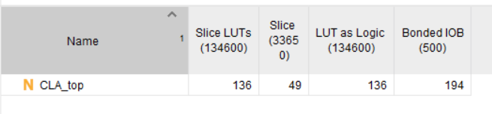
Implementation Utilization Analysis:
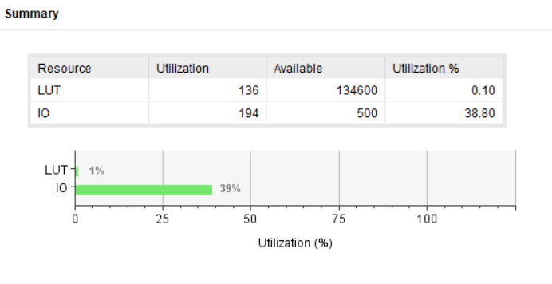

Limitations:
- Any value of the parameter “DATA_WIDTH” must be a logarithmic scale of 4 (e.g. 4, 16, 64, 256, … etc.) otherwise the design will not work as expected.

Contacts:
- All code sources, with the latest updates, and analysis are provided in my GitHub Mustafa11005/CLA_64_Bit
- Email: elsherifmustafa04@gmail.com
- LinkedIn: Mustafa El-Sherif | LinkedIn

Acknowledgments
[1] Computer arithmetic _ algorithms and hardware designs -- Parhami, Behrooz -- Oxford series in electrical and computer engineering, 2nd (Chapter 6)

